Tutorial Questions - Consolidated Account

QUESTION 1: Full Acquisition

On 31 May 2018, A Ltd pays £35,000 to acquire all of the shares of B Ltd. The statements of financial position of the two companies just after this transaction are as follows:

A Ltd B Ltd
£ £
Assets
Non-current assets
Property, plant and equipment 200,000 27,000
Investment in B Ltd 35,000
235,000
Current assets 109,000 12,000
344,000 39,000
Equity
Ordinary share capital 250,000 30,000
Retained earnings 58,000 5,000
308,000 35,000
Liabilities
Current liabilities 36,000 4,000 344,000 39,000

Prepare a consolidated statement of financial position as at 31 May 2018.

QUESTION 2: Part Acquisition
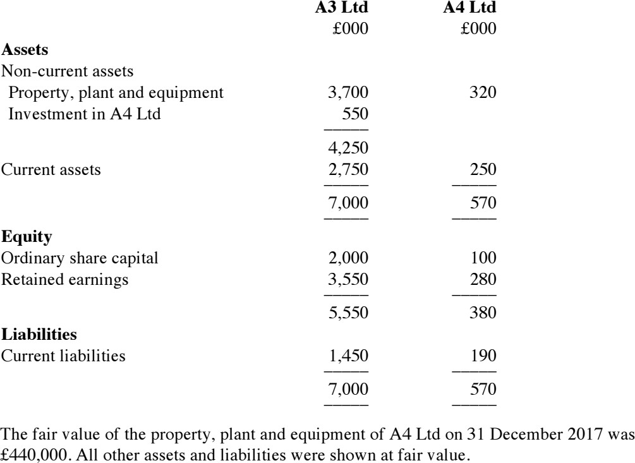
On 31 December 2017, A3 Ltd paid £550,000 to acquire 80% of the ordinary share capital of A4 Ltd. The statements of financial position of the two companies just after this transaction were as follows:

Required:
Prepare a consolidated statement of financial position as at 31 December 2017.

